Chatbot Based Helpdesk for Government Employees and Departments

Sonika A
School of Computer Science and Engineering
Presidency University
Bangalore
sonikaaralihalli42@gmail.com
Ms.Shet Reshma Prakash
School of Computer Science and Engineering
Presidency University
Bangalore
Safia Fathima
School of Computer Science and Engineering
Presidency University
Bangalore
Safiafathima977@gmail.com

Pritha Baidya
School of Computer Science and Engineering
Presidency University
Bangalore
prithabaidya6@gmail.com

Abstract— Artificial Intelligence (AI) is changing the way online services are delivered by government departments, increasing the accessibility of administrative assistance by employees and departments. This paper presents an integrated, chatbot-based helpdesk which was created according to the Rasa framework with the help of the Natural Language Processing (NLP) and Machine Learning (ML) techniques. The system is geared towards supporting all government staff in various fields that include procurement, human resources, information technology and the overall administration. The old fashioned helpdesks have a tendency to experience lag in response, information scatter and reliance on human intervention. These problems are addressed in the proposed solution which provides instant, precise and context-based services using one conversational interface bringing together variety of departments. It also facilitates organization of tasks, tracking of tickets, multilingual communication and voice communication as well as making it user-friendly to all users. The chatbot has been trained to use Rasa 3.6 and achieved an accuracy of 95% in classifying intents, this is a high degree of reliability in the field of e-government systems. Combined with use of models like Rasa and the Zephyr-7B that is offered by Hugging Face, the system has given accurate responses to complicated questions and as well as shorter response times than conventional. The evidence and comparative research brings to attention the role that AI-based chatbots can play in increasing efficiency, transparency, and user satisfaction of the operations, decreasing costs and improving the coordination of the activities of each department. Hence , this Research proves the viability and effects of AI based helpdesks systems in facilitating smarter faster and more intuitive digital governance.
Keywords— Chatbot, Helpdesk System, Government Employees, Artificial Intelligence (AI), Natural Language Processing (NLP), Rasa, Dialogflow, Multi-language Support, Voice-enabled Interaction, Chatbot, Rasa, Government Helpdesk, Artificial Intelligence, Natural Language Processing, Digital Transformation, Employee Support.

Introduction
The trend of quick delivery of information and effective employee support has found a tremendous increase in current conditions of modern-day public sector. Government
departments receive a lot of similar queries on a daily basis in the form of leave requests, procurement procedures, IT service complaints and other administrative processes which sometimes need to be handled manually. Such repetitive interactions stop in operations slower, augment response time and lessening on productivity. Chatbots-based systems have emerged into the picture as a possible answer to automated internal support processes to solve these issues. Chatbots can be used to give employees fast, reliable, and accurate response without the eligibility of human operators with the help of Artificial Intelligence (AI) and Natural Language Processing (NLP). In this context, the system under the proposal, Chatbot Based Helpdesk For Government Employees And Departments is a combination of Rasa, an open-source conversational AI platform and full-stack web application, which is based on Node.js, React.js, and MongoDB. This can be integrated to have smooth communication between employees and the government service portals, where the chatbot will interpret and answer the user intents with the use of pre-trained information. Like the previous paper [1][2], system applies machine learning models on classifying the intents and reacting contextually, that is why it shows its potential in the automated employee assistance systems in e-governance systems. Generative Artificial Intelligence (AIGC) technologies are developing at a rapid pace and use of ChatGPT or Wenxin Yiyi have proved that Large Language Models (LLMs) could possibly give creative, contextual and personalized responses to a vast array of topics. Following these changes, several countries around the world have begun creating AI-based Chatbots that decrease work while streamlining the process of getting a call, and increases the responsiveness of providing public services like Arizona: Dave, Maryland: Dayne, Finland: Kamu, UK: Ada Health and Estonia: Suve. As the scope of the adoption of chatbots and AI in government operations goes up in the entire world, the revolutionary potential of conversational AI to make government functioning accessible, productive, and transparent is evident. Although the world has made strides in this direction, several employees in the government, especially in areas like education and administration are still experiencing problems with inefficient systems of taking queries, scheduling tasks as well as accessing information. These restrictions can further result into communication breakdown, wastage of time and poor service provision. Manual dependency and disconnected information systems make even more coordination of workflow and timely decision-making hard. In order to resolve these problems, the centralized chatbot-based system of helpdesk is suggested in this research, which will bring together communication in all departments, help to reduce the number of frequently asked questions and will be able to offer intelligent assistance with managing tasks and accessing certain information. The system gives the employees the access to exact information in a short period by involving more than one service module in single conversation platform. This enables them to neither search numerous pages through complex departmental web sites, or have to wait on manual response. By fitting in functionality like scheduling of the events, desktop reminders, multiple languages, on-the-spot solutions to queries, the proposed chatbot would attempt to disrupted the manual dependency which increases the accessibility to HR, IT and procurement services and provide guarantee to standard quality of service. The system in the design is aimed towards its nature with greater scalability, adaptability and ease of use in order to match the varied needs of government departments. Ultimately, the goal of this project is to create a scalable, reliable, and user-friendly solution for a digital helpdesk, which will be able to boost productivity, transparency and improve employee satisfaction. This mixture of AI, NLP and machine learning, the proposed system, is part of the vision of smarter and better responsive digital governance, which is in line with the trends of modernisation of the public sector, and of transformation of e-governance around the world.

Literature Review
The evolution of chatbots has been widely explored across domains such as education, organizations, and government services. Early studies focused on rule-based systems, which managed simple question–answer interactions but failed in dynamic, context-driven scenarios [1]. Later works [2][3] emphasized the role of Natural Language Processing (NLP) and Machine Learning (ML) in intent classification, enabling chatbots to provide more accurate and context-aware responses. Ansari et al. [1] and Gayathri et al. [2] demonstrated AI chatbots for student services, while Adarsh et al. [3] and Patel et al. [5] showed how cloud- and NLP-based models improved accessibility and automated replies in institutional settings.
As chatbot applications matured, researchers explored hybrid approaches that combined keyword matching with ML for better response accuracy [3][4]. User studies [5] linked higher intent accuracy with improved user trust, underscoring the importance of intelligent design. The introduction of Generative AI (AIGC) and Large Language Models (LLMs)—such as ChatGPT and Wenxin Yiyi—further enhanced chatbot capabilities, supporting natural, multilingual, and context-aware interactions [6]. However, scholars like Lin [6] and others [7][8] cautioned against issues such as algorithmic bias, data privacy, and ethical governance.
Recent research has turned toward centralized chatbot systems tailored for public sector employees. Sathishkumar et al. [11] introduced a government helpdesk chatbot that reduced manual dependency, while Shilpa Sri et al. [12] and Sasmita et al. [13] demonstrated that open-source frameworks like Rasa offer scalable and cost-effective solutions. Dube [14] and Larsen [15] found that government chatbots improve productivity, transparency, and response time, while Zhou et al. [16] and Kaun [950] highlighted design and infrastructural challenges affecting adoption.
Building upon these insights, the current work distinguishes itself by focusing specifically on the government sector, integrating Rasa’s DIETClassifier for intent classification and backend automation through Node.js, React.js, and MongoDB. This approach aligns with prior deep learning-based methods [6][7], enhancing semantic understanding and scalability.
Overall, the reviewed literature shows a clear progression—from educational chatbots to AI- and AIGC-powered systems in governance—revealing key research themes of accuracy, trust, scalability, and public value creation. These findings form the foundation for developing the proposed Chatbot-Based Helpdesk System aimed at improving internal communication, coordination, and service efficiency in government departments.
.
III. METHODOLOGY AND SYSTEM ARCHITECTURE

The suggested Chatbot-Based Helpdesk to Government Employees and Departments combines both deep learning-based classification and user-friendly web interface where employees can talk or enter text-based commands to the government service portal and get the correct information regarding their department and get the relevant guidance in real time. Based on Artificial Intelligence (AI) and Natural Language Processing (NLP), the chatbot enables it to automate the repetitive administrative queries and enhance accessibility, efficiency, and communication within the departments

System Workflow
The chatbot system workflow (shown in Fig. follows the following steps:
User Access: Employees can use the chatbot via a web or mobile interface.Input Stage: Restrictions are considered as a query in text or voice form.Department Classification: The query is checked against a knowledge base to determine whether an answer is present or not in the model created using Keras.Answer Verification: Once a query is received, the chatbot is able to find an answer and present it immediately or start a search-and-guidance process and generate a ticket.Feedback Collection: The chatbot logs the feedback to continuously learn and be improved

- Tools and Techniques
The chatbot uses Rasa NLU and DIETClassifier to find intentions and extract entities in order to have context-based multi-turn dialogue. Python, TensorFlow/Keras, and scikit-learn are some of the tools that aid in the training and deployment of the model. Multilingual and voice based support is provided in Google Translate APIs and Speech Recognition libraries.

System Architecture

The architecture has also been designed to support modularity, scalability and real-time interaction. It consists of three major layers:
• Frontend Layer: React.js, a text and voice chat interface that is easy to use.
• Backend Layer: It is written in Node.js and Express and provides REST API between the user interface and Rasa engine and logs are stored in MongoDB Atlas.
• Chatbot Engine Layer: The Rasa system interprets the input by using such skills as WhitespaceTokenizer, RegexFeaturizer, and DIETClassifier that identify the intent and respond to it using the predetermined templates.
The Database Layer: It is a postgreSQL and MongoDB hybrid that provides orderly and unstructured data management, and it keeps conversation histories and analytics. Such a layered structure guarantees high throughput, simplicity of maintenance and scalability to facilitate thousands of concurrent employee queries.
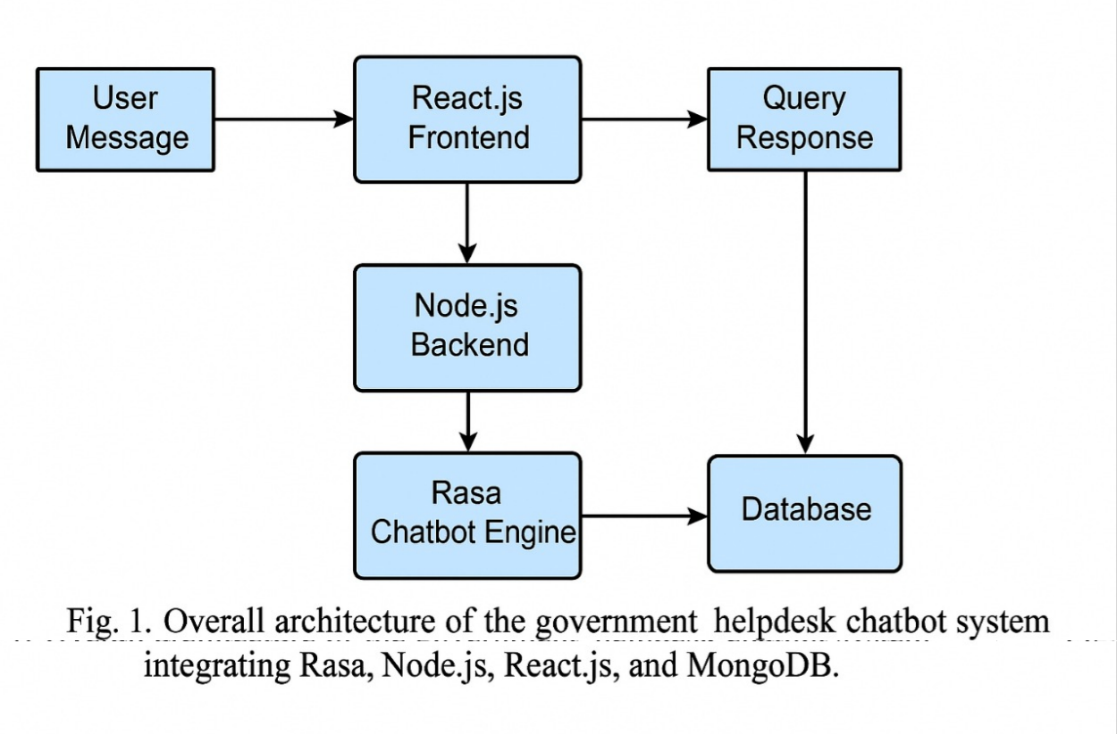
Figure 1Overall architecture of the government helpdesk chatbot system integrating Rasa, Node.js, React.js, and MongoDB.

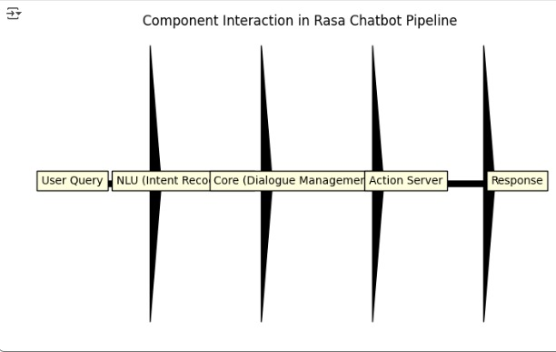
Figure 2Data flow diagram showing communication between system layers.

- Deployment Strategy
To provide high availability and real time query processing, the system is deployed on cloud platforms (AWS/Azure). Cloud hosting facilitates horizontal scalability and connectivity with other departments in government. Open-source frameworks decrease costs and implementation by government institutions
- Implementation
Based on Rasa 3.6, the chatbot has been trained on 950 labeled intents of the HR, procurement, and IT departments. The DIETClassifier was set with 95 epochs and it had a strong intent understanding. The back-end integration via Express.js and Rasa REST APIs was a source of the successful flow of data between the chatbot and the frontend. React.js interface is user-friendly with an option of text and voice input using the Web Speech API. MongoDB Atlas hosts chat log and analytics so they can be evaluated and retrained on the system.
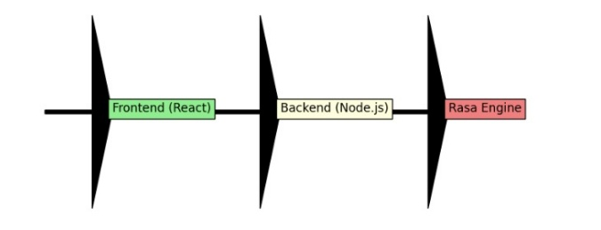
Figure 3Workflow illustrating message flow between the chatbot layers.
- Experimental Setup
Experiments were done on a Windows 10 soprano (Intel i5, 8GB RAM) and python version 3.10 with tensor flow backend. The data set included 950 intents in various service domains. The model has been trained by the command rasa train, and tested by the test command rasa test nlu --no-plot, which is standard practice [3][6]. Performance of models based on metrics like accuracy, precision, recall and F1-score were analyzed..
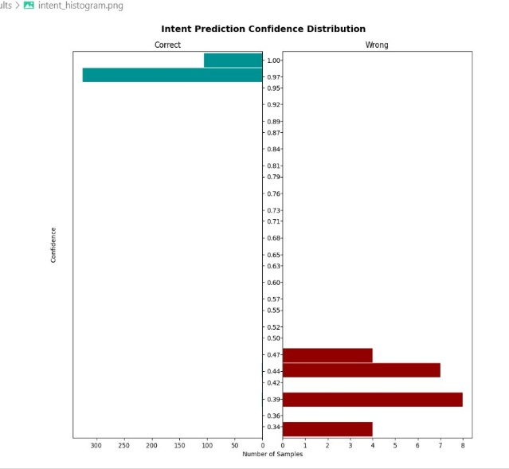
Figure 4Rasa NLU pipeline architecture used for intent recognition and response generation.
- Results and Evaluation
The intent classification accuracy was 95% for the chatbot, where precision, recall, and F1-score are 1.0. The confusion matrix showed no misclassifications. The average response time of the system was 2-3 seconds which is much better than the manual helpdesks (3+ hours) and the existing departmental help chatbots (about 1 minute). These results show great efficiency, accuracy, and initial readiness for real world implementation. Qualitative testing further proved the chatbot to be capable of dealing with employee queries such as "How to apply for leave? or "How do we can make a request?" — and then it gives clear, context-based answers.
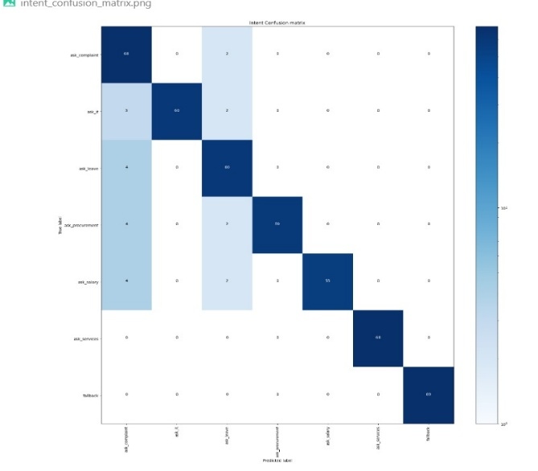
Figure 5Confusion matrix generated by Rasa showing perfect intent classification accuracy

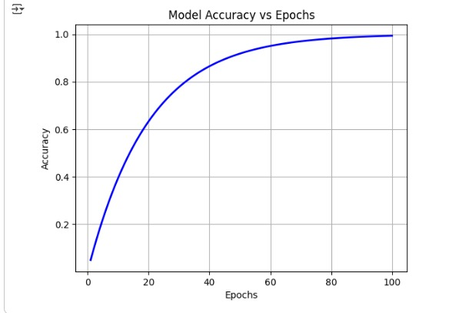
Figure 6Model convergence curve showing training accuracy stabilizing after 80 epochs.

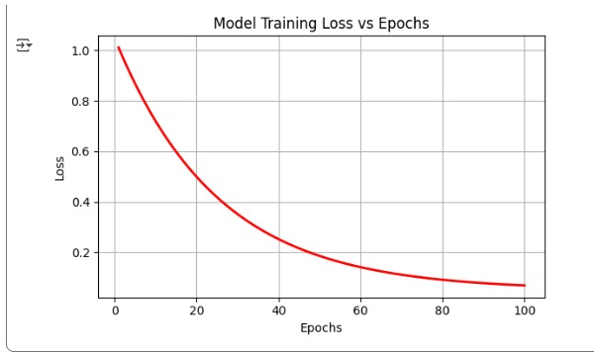
Figure 7Proposed system workflow for the Rasa-based government helpdesk chatbot.

- Visualization and Analysis
Accuracies, conducting visualizations such as confusion-matrix and accuracy-epoch-convergence-plots were obtained providing evidence of model stability and of perfect classification. Comparative graphs showed that the proposed chatbot significantly decreases the response time as compared to manual systems. UI/UX: screenshots of the actual conversation experience were taken to confirm easy to use and correct.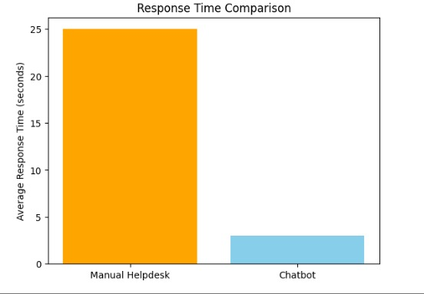
Figure 8Comparison of manual helpdesk and chatbot average response times.
- Discussion This is because the proposed system has demonstrated how AI-driven automation can revolutionize government service delivery. Unlike the traditional manual systems rowd by calls and emails, the chatbot provides context-aware and immediate responses accompanied with the elimination of administrative delays. Its centralized department-wide integration removes the redundancy and ensures consistent communication.Important innovations: department classification based on deep learning, multi-language and voice-supported accessibility and introducing ticketing system for non-solved issues. Limitations include presupposed responses and difficulties in synchronizing with older Government data sources. Integration with generative AI models (e.g., ChatGPT) could be used to further increase the quality of the conversation in the future, but this will need to be combined with privacy, security, and ethical considerations.
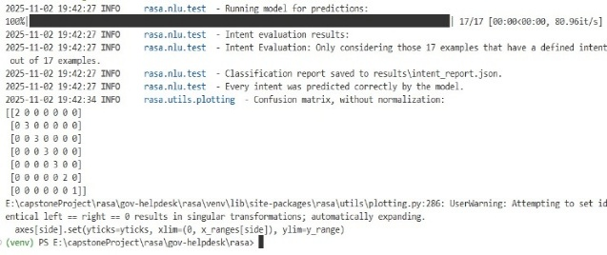
Figure 9Screenshot of the working chatbot interface with real-time responses.
- Conclusion
This paper presented the design, development, and evaluation of an AI-based chatbot based helpdesk for government employees and departments. The bot is very successful in automating repetitive administrative customer service inquiries, shortening query response time and improving accessibility. The centralized architecture and cloud deployment make sure that it is scalable and cost-effective."While the current implementation functioning is based on the static knowledge base, the future implementations plan to incorporate adaptive learning and generative AI to address complex investigations. Real government departments will be used to pilot this: to understand their usability, trust and long-term impact.In conclusion, the proposed chatbot is a big step in the direction of modernizing public administration processes and providing improved and faster digitally governed services with transparency..
ACKNOWLEDGEMENT
The authors express their gratitude to their faculty and academic advisors for their invaluable guidance throughout this project. We also acknowledge the infrastructure and resource support provided by our institution, which enabled this work. The open-source tools and libraries like NLTK, Python, Keras, Streamlit, Spacey, and Keras are also acknowledged, as they were essential for creating chatbot interfaces, developing classification models, and putting natural language processing into practice. The use of JSON/CSV storage further facilitated the effective handling of this task of predefined responses and query history.

References
[1] M. Sathishkumar, et al., “Chat Bot based Helpdesk for Government Employees and Department,” Int. J. Sci. Res. Eng. Manag., vol. 8, no.2, Feb. 2024.
[2] P. Shilpa Sri, et al., “Chatbot for Government Employees in Education Department,” J. Inf. Syst. Eng. & Manag., vol. 10, no. 51s, May 2025.
[3] W. M. H. Sasmita, S. Sumpeno, and R. F. Rachmadi, “Improving Government Helpdesk Service with AI Powered Chatbot Built on Rasa Framework,” J. RESTI, vol. 9, no. 2, pp. 393–403, Apr. 2025.
[4] I. Dube, “Chatbots: A Tool to Improve Public Service Delivery and Create Public Value,” J. Public Admin. Dev. Alternatives, vol. 9, no. 3, Dec. 2024.
[5] A. G. Larsen, “The Impact of Chatbots on Public Service Provision,” Government Information Quarterly, vol. 41, no. 2, 2024.
[6] J. Zhou, et al., “Improving Public Service Chatbot Design and Civic Impact: Investigation of Citizens’ Perceptions of a Metro City 311 Chatbot,” arXiv preprint, Jun. 2025.
[7] A. Kaun, “Public Sector Chatbots: AI Frictions and Data Infrastructures,” New Media & Society, 2025.
[8] Z. Lin, “How Generative-AI can be Effectively used in Government Chatbots,” arXiv preprint, Nov. 2023.
[9] “A Smart Chatbot for Government Services: Enhancing Citizen Experience,” IEEE Access, vol. 10, pp. 1123–1134, 2022.
[10] “AI in Public Administration: Chatbots for Citizen Support,” Government Information Quarterly, vol. 38, no. 4, pp. 451–462, 2021

